**Working title:**

Hamburgers of the forest hypothesis: Tri-trophic interactions and caterpillar food quality for songbirds

**People:**

Robert Clark, Chad Seewagen, Wales Carter

**Background:**

Effective wildlife conservation requires an understanding of how food resources impact on local fauna. For migratory songbirds, it has been long-established that temperate forests provide a rich source of insect prey critical for nestling development. Forest trees and shrubs support a high density and diversity of foliage-feeding insects, which are a high-quality resource high in lipid and protein content. However, despite the importance of this interaction for wildlife, relatively few studies have directly documented the insect fauna and their macronutrient composition among native hosts. The majority of historical work has examined the impact of forest structure and tree species composition, but not documented the trophic link mediated by insect communities.

The goal of this project is to quantify and compare the “indirect nutritional quality” major tree and shrub species in forests of Connecticut and New York. Indirect nutritional quality includes multiple nutritional variables important for nesting birds found in arthropod food webs on a given tree species. To start, we will determine the average lipid and protein content of arthropod communities on five focal tree species (Red Oak, Red Maple, Hickory, Black Birch, and Cherry) and compare this to metrics of bird physiological health within native songbird foraging territories.

If possible, this experiment will also include manipulation and quantification of bird effects and bird diet on a non-native shrub that has come to dominate forests in Fairfield Co., CT and adjacent areas in New York State. Japanese barberry and Multiflora rose, invasive shrubs, are poor hosts for native insect, and thus provide relatively little insect prey to native wildlife feeding on understory woody plants. In habitats where native plants have been displaced, it is expected there will be fewer insect herbivores available as food sources to insectivores like migratory songbirds, or that songbirds will be forced to invest more foraging effort into prey-searching behavior on the remaining native plants.

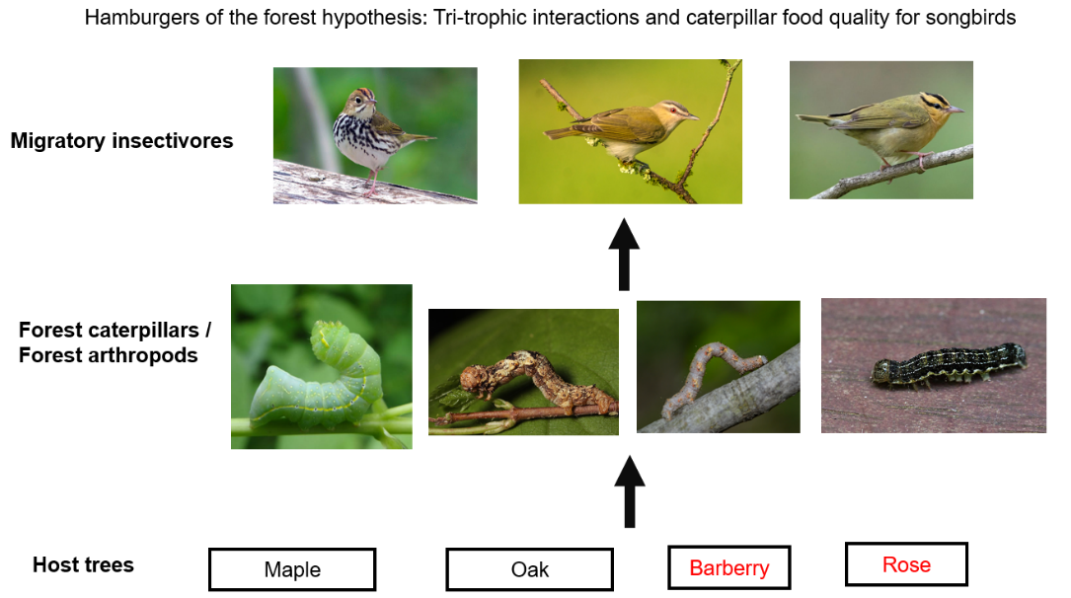

Fig 1. Hypothetical food web diagram showing bottom-up effects of plant community composition on bird health. [This is a profoundly oversimplified draft diagram. We will make it better!]

**Experimental goals:**

First, we will quantify the nutritional quality of whole foliage-foraging arthropod community on understory saplings and shrubs. Entire arthropod communities will be collected during the late spring and summer, quantified, and then analyzed for protein and lipid content. We will also quantify the abundance of insects (primarily caterpillars) that are known to sequester plant toxins as an anti-predator defense. Consequently, these data will provide a set of metrics of indirect host-plant quality for birds in our forest sites.

Second, in order to quantity the food quality on a host plant, we need to exclude birds to prevent them from taking the insects we want to study. Additionally, we seek to quantify which species caterpillar species birds may be selecting locally. To this end, as part of the first goal of this experiment, we will include a bird exclusion (bird netting) treatment and non-manipulated host plants in pairs.

Third, once plots are established and indirect host plant quality for birds is quantified, we will examine bird physiological health (blood serum protein and fecal protein) to see how forest composition impacts insectivorous songbird health at the plot level.

**Hypotheses / Predictions:**

The goals of this experiment reflect three linked hypotheses: (1) The indirect nutritional quality of trees will vary significantly among species, and this variation will be a greater determinant of arthropod food quality than variation among sites. (2) Birds are selectively taking the highest quality insects, and this will be reflected in the difference of bird exclusion vs. control treatments on trees. (3) Sites dominated by host-plant species high in indirect nutritional quality will have birds will higher metrics of lipid or protein content in diet.

**Experimental Approach:**

Surveys and bird-exclusion experiments will take place at three forest locations: Great Hollow, Pawling Nature Reserve (Nature Conservancy), and Deer Pond Farm (Audubon Society). Within each forest, we will establish 6 plots in upland forests with oak-red-maple overstory. Serendipitously, these locations have been described in detail as bird habitat including plot-level tree community composition.

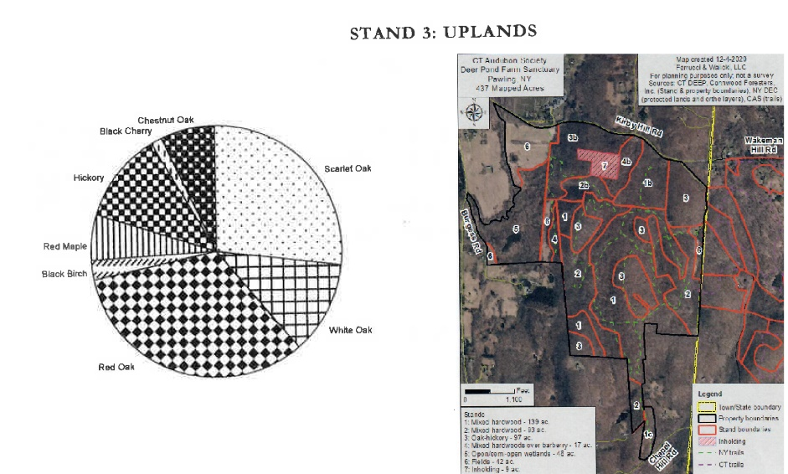

Fig 3. Example plant community composition and site map from forest inventory at Deer Pond Farm.

Experiment design will follow a similar protocol to Singer et al. 2012, but will require a partially confounded design with respect to host-plant species and bird exclusion (Fig 3). Our selection of 18 plots will be based on foraging territories of a focal generalist insectivore. While generalist insectivores are ubiquitous, it is unlikely we will be able to indenify single territories that include all tree species.

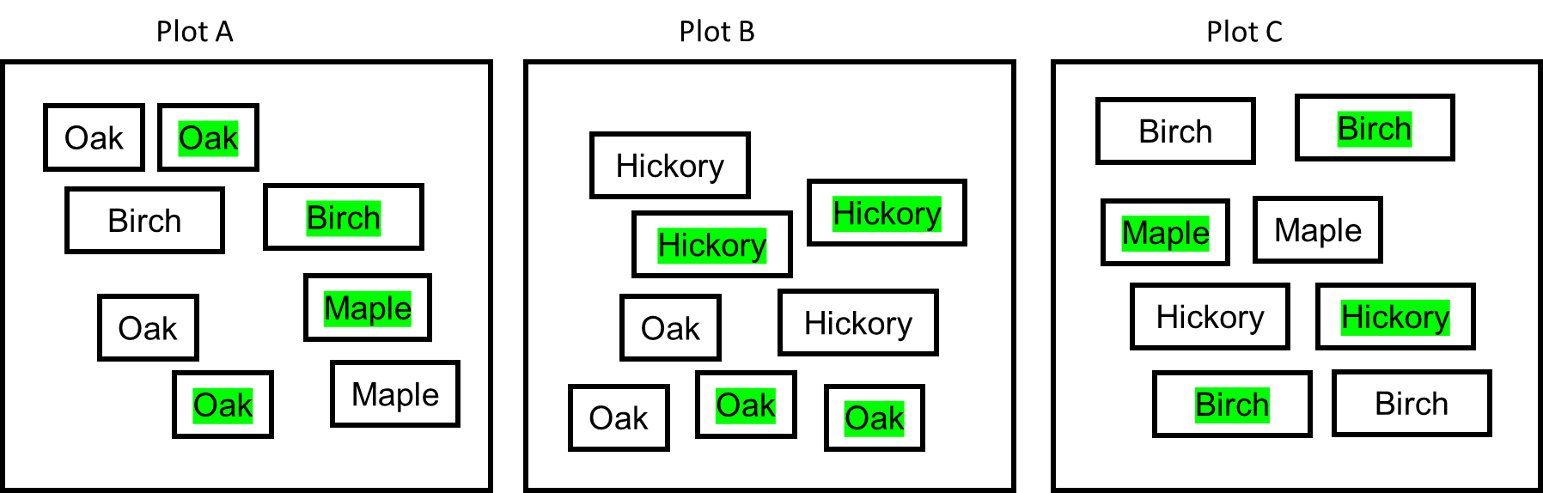

Fig 3. Putative bird territory plot design (Plots A through R, n=18). Small boxes indicate potential host trees that can be manipulated and sampled for insects, while green coloration indicates a bird-exclusion treatment.

Host plants to be manipulated will be determined during set up from a pool of candidates. The potential species pool to consider includes native trees genera found in upland habitats (Birch, Oak, Maple, Cherry, Beech, Ash, Hickory). Shrubs include natives like Witch-hazel and Hop-hornbeam, while non-native shrubs include Barberry, Burning Bush, Autumn Olive, and Multiflora Rose. At minimum we will manipulated 3 pairs of trees (6 branches) for each tree species in a given plot. Consequently, the branch-level sample size will be 3 x 2 x 18 x 3 = 324. Each tree will be sampled three times for a repeated measures design, bringing the total sampling events to 972.

216

27 netted, 27 bagged for 4 species of plants

24 netted, 24 bagged for 5 species of plants

6

48

8 trees per plot

Insects will be collected *via* branch beating and crawling or sessile arthropods will be collected directly into vials. Common caterpillar species abundance information will be tabulated when these entire arthropod community samples will be returned to the lab. All insects will be frozen at -20c for later nutritional analysis. Data collected from insects in terms of indicators of nutritional quality of insects: mass, omega-3 fatty acids (processed by collaborators at Sacred Heart), and protein content at the branch-level. These data will also consider species-identity effects of caterpillars for species that can be identified in the field, particularly specialist caterpillars that sequester tannins known to be avoided by birds.

Data collected from birds at each plot to test indirection nutritional quality: use a ubiquitous bird species known to be caterpillar specialists like Red-Eyed Vireo (*Vireo olivaceus*) plus opportunistic collection of insectivorous songbirds like Ovenbird (*Seiurus aurocapilla*). Blood samples can be taken from netted songbirds and fecal samples from collected birds. Point counts can be completed after caterpillar sampling to quantify bird species richness (“biotic integrity indices”).

**Statistical Analyses:**

There will be two phases of statistical analyses. First, we will employ a traditional linear mixed modeling approach (GLMMs) using the glmmTMB package in R. A hypothesis-testing approach will determine the relative strength of bird predatory effects on arthropods, identify the host-plant specific differences in arthropod nutritional quality among plant species, and examine if indirect nutritional quality of host-trees impacts bird health. Using a model selection and spatial framework following Clark et al. 2019, we will use path analysis (piecewiseSEM package) to determine the bottom-up effects of landscape factors and plant nutritional quality on songbirds.

Second, once we have data on bird health, we will use arthropod and plant data will be used to train an ecological forecasting algorithm using the machine-learning package ‘caret’ in R. The primary data collected in this experiment will be set aside as “training” dataset, where an additional small pool of bird health samples will be taken at locations outside those included in the primary survey opportunistically (“validation data”). The validation data will be used to assess the accuracy of the indirect nutritional quality as a predictor for songbird health and therefore a set of metrics that can be used in wildlife management plans.

**Timeline / Replication:**

See attached Excel file.

**Strengths and opportunities:**

To assess the utility of our models as management tools, the best sites for manipulating caterpillars do not have to be the same sites where our indicator birds are. Since we are assessing the nutritional quality of host plant species as a predictive model, we can go to new locations and see if there is any predictive validity. Additionally, by completed objectives 1 and 2, we will have quantified the strength of bird effects and insect community composition in a habitat types with a significantly different geological and land-use history from those examined in Singer et al. 2012 and Clark et al. 2019.

**Weaknesses and limitations:**

Sites and host plants will be confounded unless we find locations with shared plant species pools. We can address this with a mixed modeling / structural equation modeling framework as long as each host-plant species is represented at multiple sites. However, this could quickly become prohibitively complex while setting up the experiment, and thus will require careful planning at the start of each field day.

While the experiment seems overly complex, the fieldwork builds on established set of methods and simplifies some of the more time-consuming summer work. Insect samples will be frozen immediately to be processed later for lipid and protein content, and the field season will be condensed to encompass the specific breeding period of our focal songbird species.

**References:**

Singer, M.S., T.E. Farkas, C. Skorik, and K.A. Mooney. 2012. Tri-trophic interactions at a community level: effects of host-plant species quality on bird predation of caterpillars. *The American Naturalist* 179: 363-374.

Clark, R.E., J. Illan, M.S. Comerford, and M.S. Singer. 2019. Keystone mutualism influences forest tree growth at a landscape scale. *Ecology Letters* 22: 1599-1607.